IBM SMARTBRIDGE

Automatic Accident Alert System

Team:Mind Crusaders

Team Members

Vaishna S

Dona Davis

Anushka Xavier K

# INTRODUCTION

In present days the rate of accidents can be increased rapidly. Due to employment the usage of vehicles like cars, bikes can be increased, because of this reason the accidents can be happened due to over speed. People are going under risk because of their over speed, due to unavailability of advanced techniques, the rate of accidents can’t be decreased. To reduce the accident rate in the country this paper introduces a optimum solution. Automatic alert system for vehicle accidents is introduced; the main objective is to control the accidents by sending a message to the registered mobile using wireless communications techniques. When an accident occurs at a city, the message is sent to the registered mobile through mobile app in less time. Arduino is the heart of the system which helps in transferring the message to different devices in the system. Vibration sensor will be activated when the accident occurs and the information is transferred. The accident spot is identified through the mobile app. The proposed system will check whether an accident has occurred and notifies to nearest medical centers and registered mobile numbers and to the registered number. The location can be sent through tracking system to cover the geographical coordinates over the area. The accident can be detected by a vibration sensor which is used as major module in the system

# WORKING MODULE:

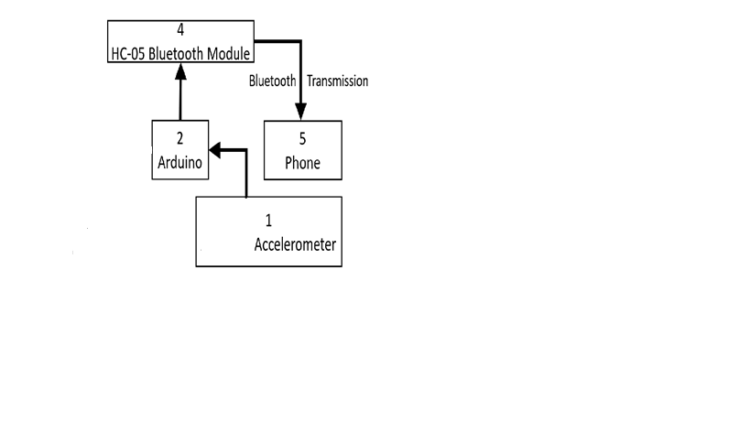

**Figure 1: Block diagram of accident detection and alert system**

# HARDWARE

* Arduino NANO
* Accelerometer ADXL335
* HC-05 Bluetooth module

# 

# SOFTWARE

* Arduino IDE
* MIT App Inventor
* MSG91

**ARDUINO:**

The Arduino UNO is a widely used open-source microcontroller board based on the ATmega328P microcontroller and developed by Arduino.cc. The arduino is the major control unit to detect or alert when an accident occurs. It collects the data from vibration sensor, and reflects the output either in display system or through a message. Here vibration sensor plays a major role. This vibration sensor will receive the vibrations of the vehicle which in turn acts as a accident detection module. Arduino gathers the information from all other modules and sends the message to the receiver.

### ACCELEROMETER:

An **Accelerometer** is added in this system for detecting an accident and its x,y, and z-axis ADC output pins are directly connected to Arduino ADC pin A1, A2, and

# HC-05 BLUETOOTH MODULE

# The HC-05 Bluetooth module and make a Bluetooth communication between the mobile app and the device. tItcommunicates with the Arduino via the Serial Communication.

# Image result for Diagram having accelerometer bluetooth and arduino uno

**Working module of accident detection and alert system**

**WORKING**

Accelerometer senses the change in the coordinates of the vehicle(x,y,z) and send the data to the mobile app to check the intensity of the accident via Bluetooth module.The mobile app detects the occurrence of the accident and send the time and the precise location(latititude,longitude) to the nearby medical centers or the ambulance drivers through SMS and thus save the victims.

**FUTURE SCOPE**

The proposed system deals with the detection of the accidents.By increasing the techonology we can also provide alert The system that can stop the vehicle to overcome the accidents.

# APPLICATIONS

The applications for this project are in navigation, automobiles, aircrafts, fleet management, remote monitoring, remote control, security systems, etc.

Vehicle scheduling

Route monitoring

Driver monitoring

Accident analysis

**CONCLUSION**

Main motto of the accident alert system project is to decrease the chances of losing life in such accident which we can’t stop from occurring. Whenever accident is alerted the paramedics are reached to the particular location to increase the chances of life. This device invention is much more useful for the accidents occurred in deserted places and midnights. This automatic accident alert feature plays much more important role in day to day life in future.